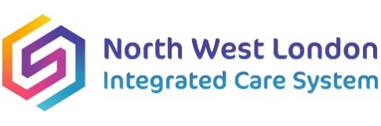

**NHS North West London Health Equity programme**

**NHS NW London Population Health Management and Health Equity Academy**

**Invitation to providers for expressions of interest (EoI) to deliver cultural competency training to staff within the NW London Integrated Care System**

Dear provider,

The NW London Health Equity programme is currently seeking expressions to deliver cultural competency training to staff within the NW London Integrated Care System.

This training is being commissioned following extensive bench-marking, mapping and engagement in this domain. This work has led to the identification of widespread gaps in skills, knowledge and capabilities within our workforce and training has, therefore, been identified as a priority system development need in supporting the delivery of effective, efficient and meaningful population health management interventions, and improving the offer of care to our residents.

The NW London Health Equity programme is seeking to engage and collaboratively work with a provider who can deliver against the required inputs, outputs and outcomes as documented in the attached specification of work:



Interested providers will need to be able to:

* provide a specification of work (SoW) that describes the proposed workshop delivery offer and which aligns with the NW London specification
* provide a costings breakdown for both the individual elements listed in the NW London specification and the total overall cost (e.g. content development/individual session etc)
* provide a provisional timeline for delivery, noting that training and support needs to have been commenced before the end of this financial year (i.e. before the end of March 2025)
* recognise the content of the NW London specification but be able to work flexibly and collaboratively with the Health Equity programme to ensure we create the right content, approaches and timelines that maximise participation, positive outcomes and learning for our staff
* actively contribute to and, where required, take a lead on collecting data and participant feedback to support evaluation, and ensure learning and feedback is embedded in any future training delivery

If you are interested in completing an expression of interest, please note that these need to be received by the Health Equity team by ***5 p.m. Wednesday 19th March 2025.***

Completed expressions of interest should be sent to Matthew Harmer, Head of Population Health Management, NW London ICB at [Matthew.harmer@nhs.net](mailto:Matthew.harmer@nhs.net)

Should you have any questions regarding completion of your expression of interest please contact Matthew Harmer at the above email address. We would encourage and welcome potential providers to engage in an informal pre-submission discussion.

Many thanks and on behalf of the NW London Health Equity team,

Matthew.